5 November 2020

Mr Steven Avery,  
Executive Director,  
Heritage Victoria,  
8 Nicholson Street,  
East Melbourne, Vic 3002.

[heritage.victoria@delwp.vic.gov.au](mailto:heritage.victoria@delwp.vic.gov.au)

Dear Steven,

Permit Application Number P31711

H0703: Former Hoffman Brickworks, 72-106 Dawson Street, Brunswick

The Royal Historical Society of Victoria notes application P31711 for a permit to demolish the Brick Pressing Shed (Building 5) and Former Engine House (Building 6) and construct a seven-storey replacement building with rooftop garden. In view of the significance of the building and the recent history of the developer’s actions, we are astonished that they should apply for a permit to demolish the remaining heritage fabric and replace it with, at best, a Disneyworld fantasy substitute. We strongly support the objection submitted by Moreland Council in August 2020 and consequently we urge you to refuse permit application P31711 and to do all in your power to ensure that the developer adheres to the 1999 CMP.

Hoffman’s Brickworks has been on the Victorian Heritage Register since 1989. It is an important part of Victoria’s industrial heritage and was the source of many of the bricks used to construct Victorian buildings in the 19th and 20th centuries. The brickworks provided employment to many during the long years of its operation. The chimneys are an important local landmark.

A Conservation Management Plan drawn up in 1999, following the end of brick-making operations and the sale of the site in 1996, provided for the retention of historic buildings and of the historic machinery in situ. (Machinery in the shed is essentially as it was when brick production ceased in 1993 and dates from many decades before that.) The owner/developer agreed to the CMP. In 1997 Moreland Council made a $400,000 grant to assist the owner/developer in fulfilling the CMP. In 2003, Council and the owner/developer entered into an agreement whereby Council allowed subdivision of the brickworks precinct and in exchange the owner promised to retain and conserve the heritage buildings in the development.

Subsequently, notwithstanding this agreement, the owner/developer demolished Kiln 1 (in 2002), converted Kilns 2 and 3 into apartments and demolished the Gatehouse (both 2008). Heritage Victoria and Moreland Council accepted this reluctantly, on the understanding that profits from the resulting new buildings would be used to retain and restore the remaining heritage buildings.

The owner/developer failed to carry out this restoration and indeed failed to secure and maintain the complex. As a result, a fire damaged the roof cladding and structure of the Brick Pressing Shed (Building 5) on 24 March 2018 and the roof of the Former Engine House (Building 6) collapsed on 12 June 2020. These buildings, and the associated machinery, were assessed in the CMP as of primary significance to the site. They are the only original, unaltered buildings remaining on the site.

The owner/developer now proposes to demolish the Brick Pressing Shed and replace it with a kind of replica building in which the machinery would be displayed as an interpretation centre. The Heritage Impact Statement (HIS) and the Assessment of Reasonable or Economic Use seek to justify demolishing the shed by claiming that the contaminated soil can’t be removed without demolition. This vague claim is not substantiated. The HIS claims that ‘remediation without demolishing the structure is not possible’ (p. 1). The Assessment simply states that, ‘Given the structural condition of the buildings, demolition is required to comply with the EPA’s clean up notice’ (p. 1). Neither offers any evidence for this assertion.

We do not accept the assertion in the Assessment that retention ‘is simply unviable and not an economic outcome given the demolition and remediation costs that are required to comply with the EPA notice’ (p. 16). The report arrives at this conclusion by sleight of hand, as follows. First, the report argues that the alternative to the current proposal is Option 2, development as per the previous permit (MPS/2008/313, since expired—p. 5). Option 2 includes 20 strata offices over two levels (total floorspace 830 sqm (p. 6). Second, the report argues from the census that, in this area, there will be ‘likely subdued demand for traditional commercial office provision’ (p. 10). Third, the report concludes that ‘refusal of the permit and construction in accordance with the endorsed plans (Option 2) would deliver a relatively traditional commercial office provision configured as a series of strata units. This does not reflect the current state of the local office market, which is immature at best’ (p. 12). The sleight of hand comes into play under ‘5.3 Results’, in a table which characterises Option 2 as ‘demolish, remediate and reinstate/refurbish and [*sic*] existing building. Assume the building has no higher and better use’ and which costs this option at a loss of $24 million (p. 14). The same table eliminates other options.

We have dwelt on this progression to highlight the report’s misleading procedure. It assumes that the only alternative to the current plan is to follow MPS/2008/313 or Option 2 and then faults Option 2 because office space is no longer viable, omitting the possibility of a new plan not dependent on office space. It then conflates the problem of remediation with the choice of office space in the developer’s Option 2 and by combining the projected failure to sell the office space with vaguely ascertained costs, comes up with the loss of $24 million. This assumes (1) that the developer would not come up with another plan, perhaps involving apartments rather than offices and (2) that the appropriate response to soil contamination is to ‘demolish, remediate and reinstate/refurbish’. The latter assumes that the only way to remediate is to demolish the historic structures.

We do not accept that demolition is the only alternative. We endorse the call by Moreland City Council for a peer-reviewed second opinion on this issue. We do not accept the HIS claim that ‘it is not feasible to dismantle the building(s), certainly not the Former Engine House portion, and to reconstruct them’ (p. 20). Is it ‘not feasible’ for economic or for structural reasons? It may be more expensive to remove the contaminated soil while retaining the Brick Pressing Shed and/or to address the structural issues in the extant heritage fabric, but expense is not in this case a justification. All in all, this report is vague and lacking in substance to the point that it cannot offer any credible economic justification for the demolition of a listed heritage building in contravention of previous agreements.

We submit that the developer could prepare a more suitable plan for current conditions that addresses any shortcoming in the proposal resulting from dependence on office space. We further submit that, given the record of this owner/developer and the extensive profits derived from the site by serial non-compliance with agreed conditions, the owner/developer should be required to bear the cost of removing the soil in order to preserve the Shed.

The owner/developer now proposes, as well, to build an eight-storey apartment building adjacent to the shed. It would be completely out of character with the other buildings on the site and would overshadow the Brick Pressing Shed (or the replica, in the owner/developer’s proposal). We submit that this building is out of scale and out of character and should not proceed.

In short, we ask you to refuse the permit application and insist on the developer’s fulfilling previous agreements. We accept that some technical issues may need to be addressed and resolved, but these should be the subject of a new permit application, prepared on the basis of expert technical advice. Expense cannot now be a justification for demolition. Refusal of this application is the only appropriate response.

Yours,

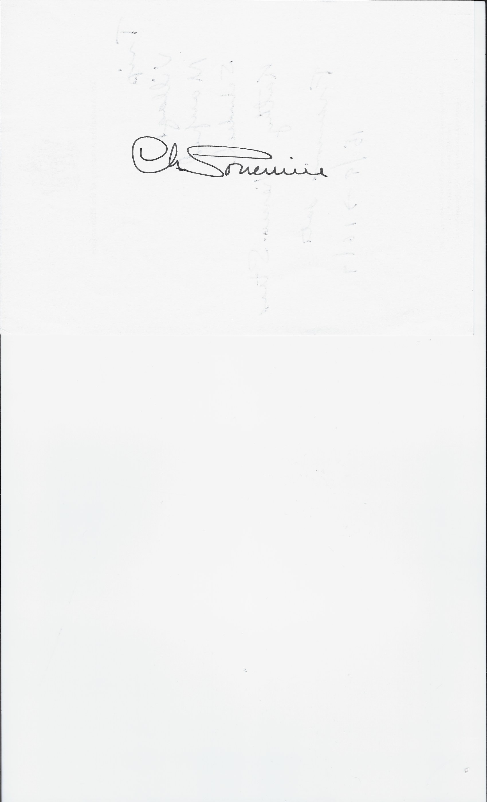

(Professor) Charles Sowerwine,

Chair, Heritage Committee,

Royal Historical Society of Victoria.